Class Name and Class List

//we should know how to get class using js and how to manipulate the classes

//what is class and id,id is unique just like our id card number whereas you can have multiple classes like blueTshirt, redpant,greyGlasses and so on you got the point right

# ClassName

//first of all it is not a function,syntax?

Elem.className=”classes classes classes”;

//and it actually replaces the whole string of classes

## INITIAL SYNTAX

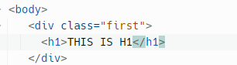

## ClassNAme

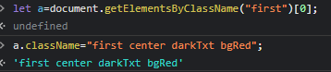



## classList();

4 Properties

.add

.remove

.toggle

.contains

